Problem statement02:

1.

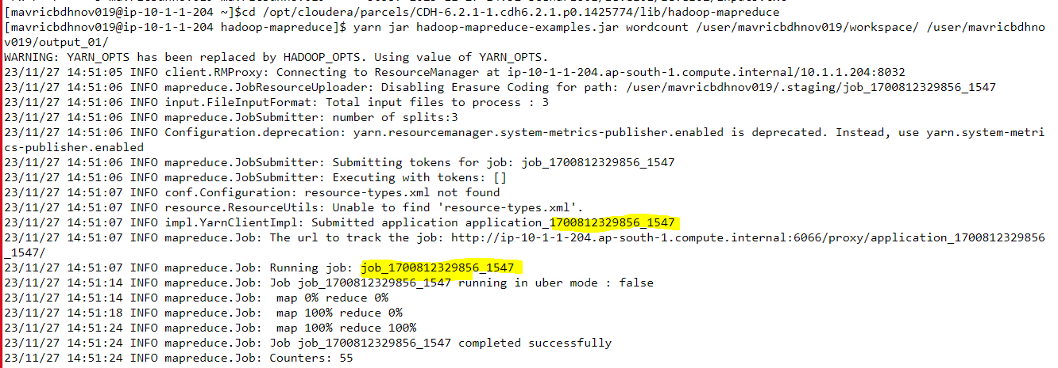

2.



3.



4.

yarn logs -applicationId application_1700812329856_1547 -appOwner mavricbdhnov019

